1. What is Knowledge Based Agent? Explain Wumpus World.

✪ Knowledge-Based Agents

Knowledge-based agents are best understood as agents that know about their world and reason about their courses of action. Basic concepts: • The knowledge-base (KB): a set of representations of facts about the world. • The knowledge representation language: a language whose sentences represent facts about the world. Teqnht  NohmosÔnh M. Koumparkhc ✬ ✫

TELL and ASK interface: operations for adding new sentences to the KB and querying what is known. This is similar to updating and querying in databases. • The inference mechanism: a mechanism for determining what follows from what has been TELLed to the knowledge base. The ASK operation utilizes this inference mechanism. Teqnht  NohmosÔnh M. Koumparkhc ✬

KB-Agent(percept) returns an action static KB, a knowledge-base t, a counter, initially 0, indicating time

Tell(KB,Make-Percept-Sentence(percept, t)) action ← Ask(KB,Make-Action-Query(t)) Tell(KB,Make-Action-Sentence(action, t)) t ← t + 1 return

We can describe a knowledge-based agent at three levels:

• The knowledge level: In this level the agent is specified by saying what it knows about the world and what its goals are.

• The logical level: This is the level at which the knowledge is encoded into sentences of some logical language.

• The implementation level: This is the level where sentences are implemented. This level runs on the agent architecture.

Example:

• Knowledge level or epistemological level: The automated taxi driver knows that Golden Gate Bridge links San Francisco and Marin County.

• Logical level: The automated taxi driver has the FOL sentence Links(GGBridge, SF, M arin) in its KB.

• Implementation level: The sentence Links(GGBridge, SF, M arin) is implemented by a C structure (or a Prolog fact).

We can build a knowledge-based agent by TELLing it what it needs to know before it starts perceiving the world. We can also design learning mechanisms that output general knowledge about the environment given a series of percepts. Autonomous agent=Knowledge-based agent + Learning mechanism

**The Wumpus World**

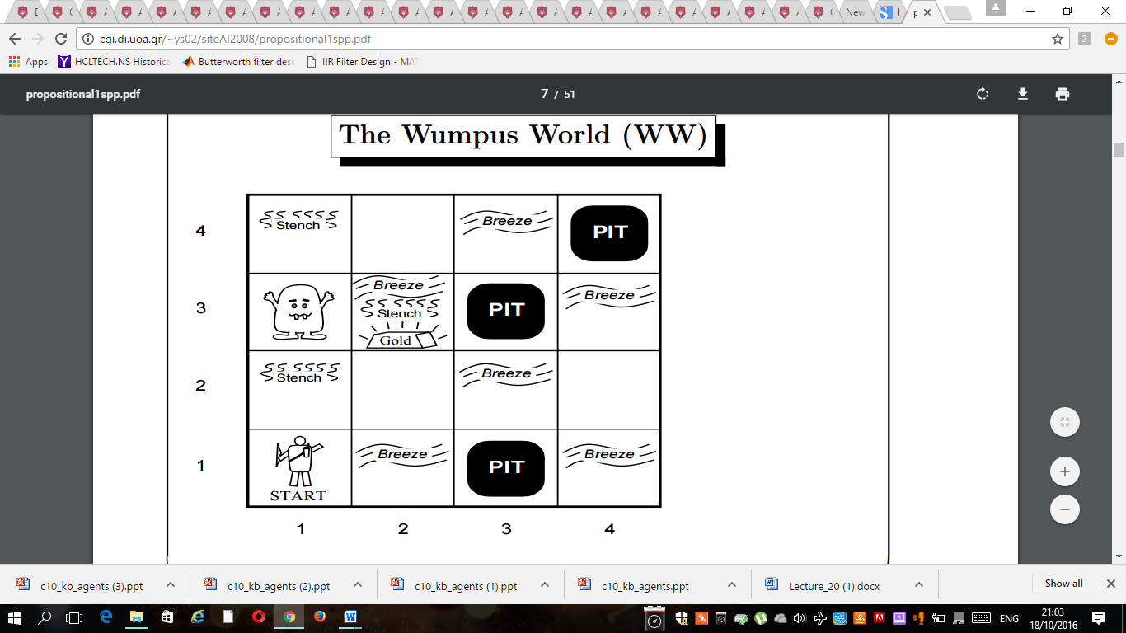

• Environment: 4x4 grid of rooms with agent, wumpus, gold and pits.

• Actuators: The agent can move forward, turn left or turn right. The agent dies if it enters a room with a pit or a live wumpus. The agent has action Grab and Shoot (one arrow only) at its disposal.

• Sensors: The percept is a list of 5 symbols: (Stench, Breeze, Glitter, Bump, Scream) Any of the above values can be None.

Reasoning and Acting in the WW

What do we need?

• A way to learn facts about the world.

• A way to represent facts and rules about the world.

• A way to reason with the existing facts in order to deduce new ones.

Examples of facts:

• The wumpus is in square [1,3].

• There is no pit in square [2,2].

• There is a pit in square [2,2] or square [3,1].

1. Explain PEAS description in detail.

PEAS

We first specify the setting.

We first specify the setting. Let’s design an automated taxi: • Performance measure: Be safe, reach destination, maximize profits, obey laws, . . . • Environment: Urban streets, freeways, traffic, pedestrians, weather, customers, . . . • Actuators: Steering wheel, accelerator, brake, horn . . . • Sensors: Video, accelerometers, gauges, engine sensors, keyboard, GPS, . . .

A medical diagnosis system? • Performance measure: Healthy patient, minimal costs, no lawsuits, . . . • Environment: Patient, hospital, pharmacy, doctors, nurses, equipment, . . . • Actuators: Screen display (questions, tests, diagnoses, treatments, referrals, . . .) • Sensors: Keyboard (entry of symptoms, findings, patient’s answers, . . .)